**PROGRAM 1**

**PROCEDUERE TO CREATE AN ANIMATION TO REPRESENT THE GROWING MOON.**

1. Open flash 8 software=> click on flash document=>go to windows=> properties=> select the properties tool=> choose the background to blank.
2. Go to fill color under tool bar=> select the white color.
3. Select the oval tool in order to draw the moon. You will get a white circle.
4. Select the white circle on the worksheet using the selection tool=> right click=> convert to symbol=> select movie clip=> give suitable name e.g.: moon=>click ok.
5. Go to filter=> click on the + symbol=> select glow to apply glowing effect=> select the color to white under glow and adjust the blur x/blur y values.
6. Click on the + symbol again and choose blur=> again adjust the blur x/blur y values.
7. Place the moon where ever you want on the work area. Double click on layer 1 and rename as MOON.
8. Insert another layer=> rename it as Animation.
9. Select fill color to black=> select oval tool and draw a circle on the moon to cover the moon=>select newly added circle=> right click=> convert to symbol=>movie clip=> name it as Animation.
10. Go to filter=> select + symbol=> give the glow and blur effect as did for moon.
11. Select the 150th frame in moon layer=> right click=> insert key frame. Repeat the same for Animation layer.
12. Click on the 149th frame of animation layer=> right click=> press create motion=> select the animation movie clip and move slowly across the moon.
13. Finally go to control=> test movie=> you will get a glowing moon as the output.

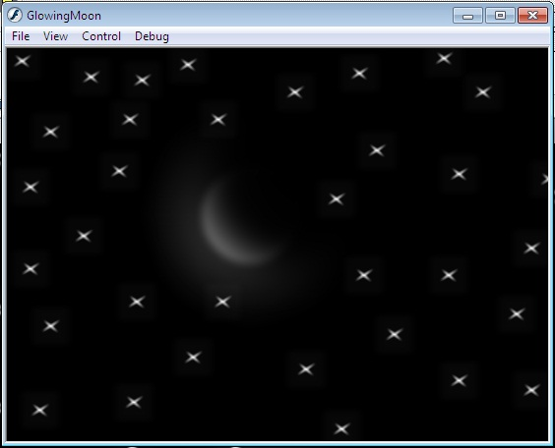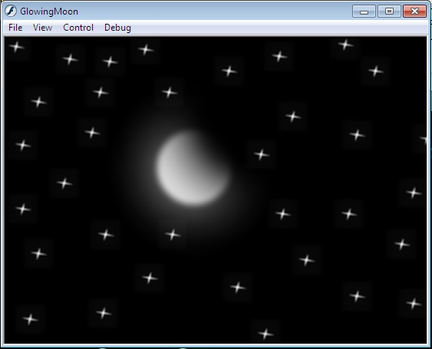**OUTPUT:-**

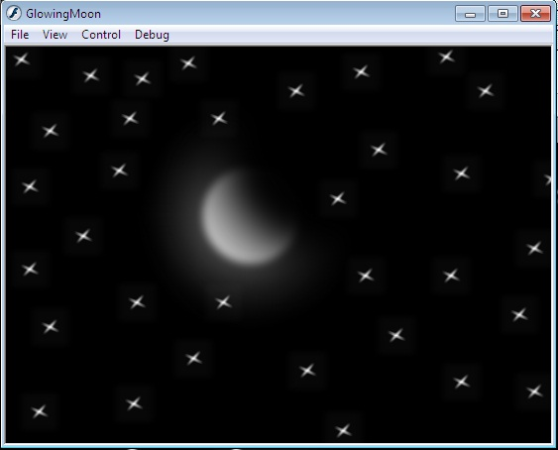

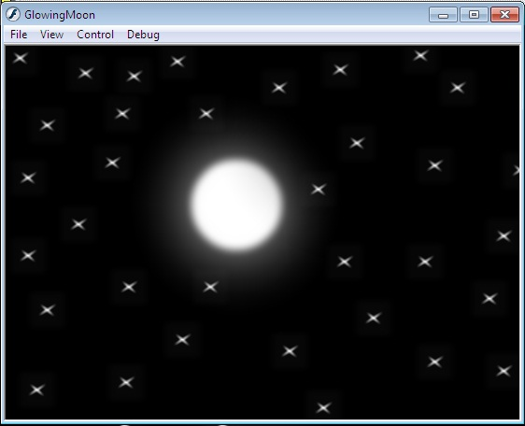

**PROGRAM 2**

**PROCEDURE TO CREATE AN ANIMETION TO INDICATING A BALL BOUNCING ON STEPS.**

1. Go **to start** => **macromedia**=> click on **flash document**.
2. Select the **line** tool and draw the steps. Color it using the paint bucket tool.
3. Select the **circle** from the tool bar and create a circle on the work area.
4. Now fill the color to the circle using the **paint bucket tool** from the tool bar.
5. Go to **frames**=> right click on the first frame and choose **insert key frame**. Slightly move the ball. Repeat the same procedure by adding new key frames to show the ball changes the shape of the ball slightly when it touches the surface.
6. In order to change the shape use the **free transform toll**.
7. Go to **control** and click on **test movies** you will observe the ball bouncing on steps.

**OUTPUT:-**

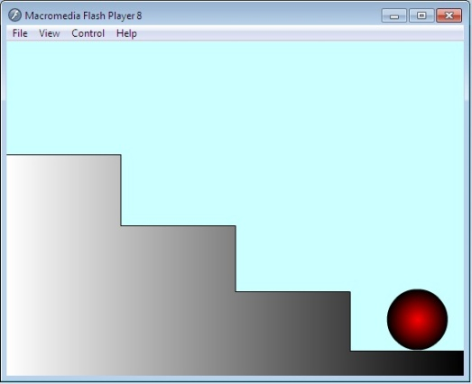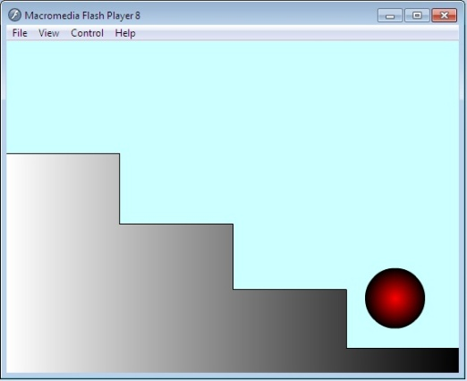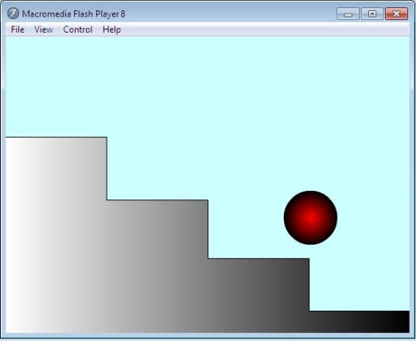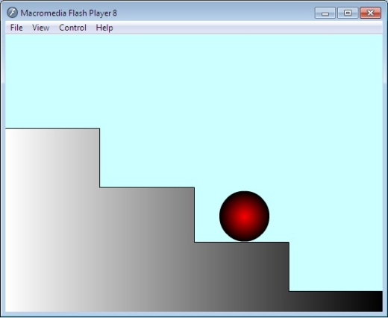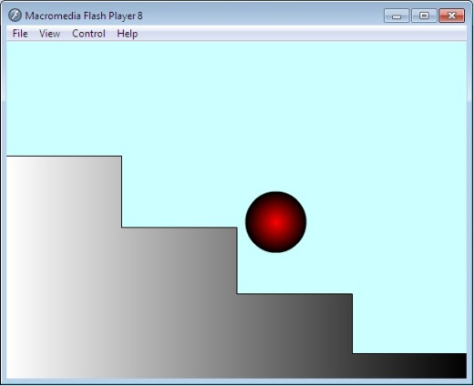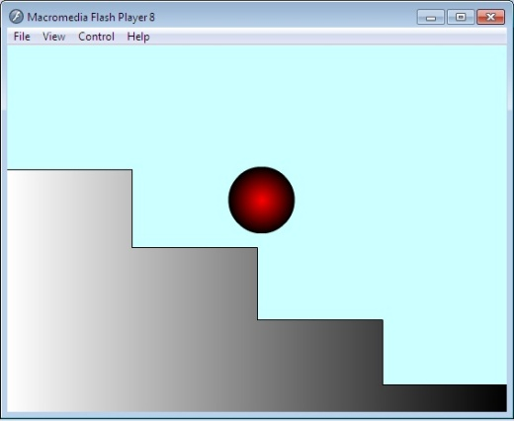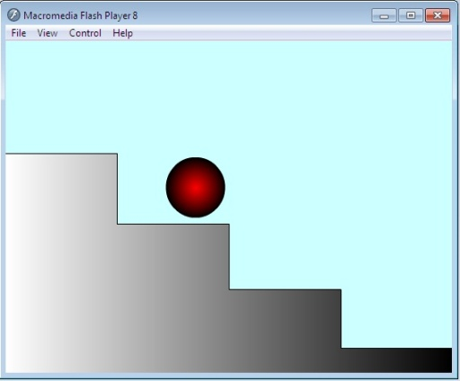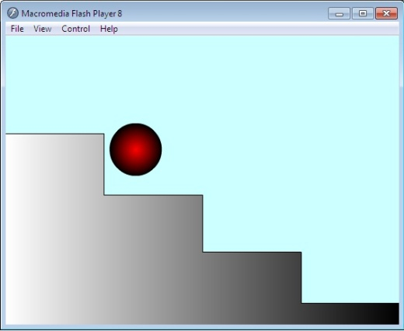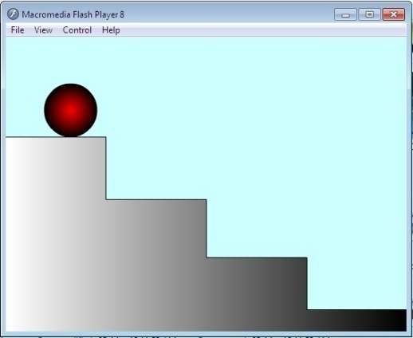

**PROGRAM 3**

**PROCEDURE TO SIMULATE MOVEMENT OF A CLOUD.**

1. Go to **start**=> **macromedia**=> click on **flash document**.
2. Create a blue background in **layer 1.**
3. Now insert a **layer 2** and draw the cloud in this layer.
4. In order to create the clouds, go to **tool bar** and select **pencil** option, draw the cloud in **layer2**.
5. Fill the color to the cloud, right click on it=> choose **convert to symbol** option=> give the name as cloud.
6. Select the **movie clip** option and click **ok**.
7. Go to **filter**=>click on the + symbol=> select **glow** to apply glowing effect=> select the color to white.
8. Under glow and adjust the **blur x/blur y** values.
9. Give the appropriate **blur** effect to the cloud.
10. Go to **frames**, insert key frame on both the layer, create the motion tween on 2nd layer and move the clouds.
11. Finally go to **control**=> click on **test movies**.

**OUTPUT:-**

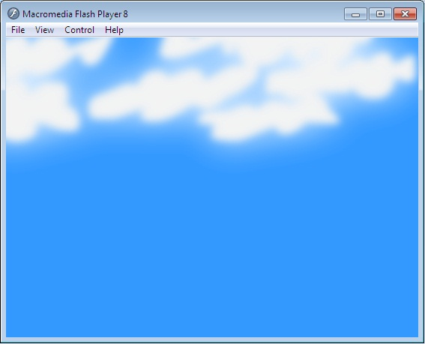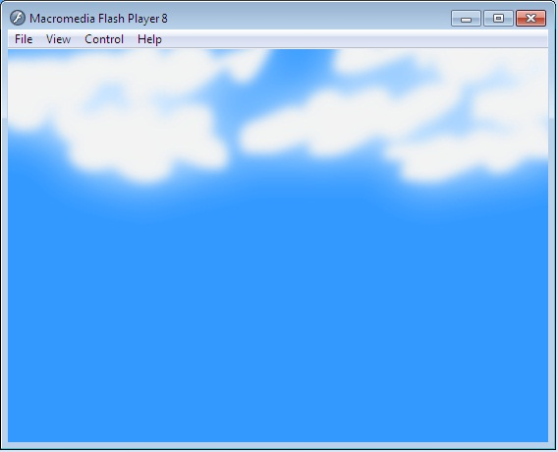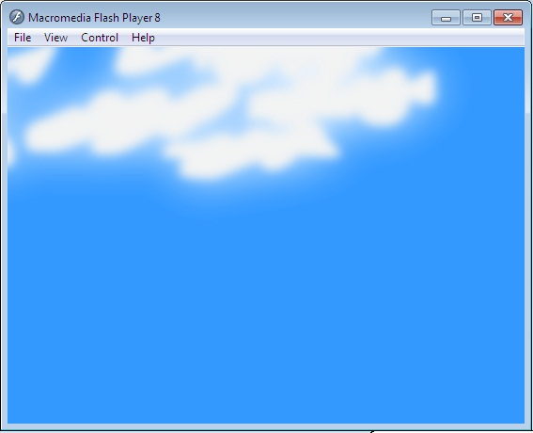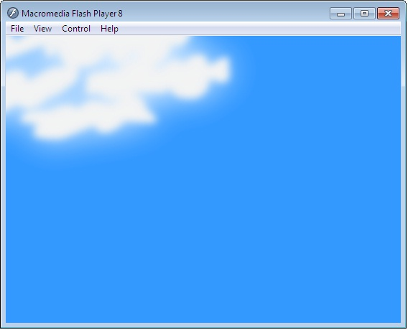

**PROGRAM 4**

**PROCEDURE TO DRAW THE FAN BLADES AND TO GIVE PROPER ANIMATION.**

1. Go to **start**=> **macromedia**=> click on **flash document**.
2. Create a background on **layer 1**.
3. Insert another layer=> draw only fan blades and its circle.
4. Insert another layer and draw fan stand.
5. On each layer right click on frame and insert **key frames**.
6. Select the fan blades layer and insert new key frame=> select the fan blades by **free** **transform** tool and **rotate** the circle a little bit.
7. Repeat the rotation until you get the fan rotation animation.
8. Go to **control**=> **test movie** to see animation.

**OUTPUT:-**

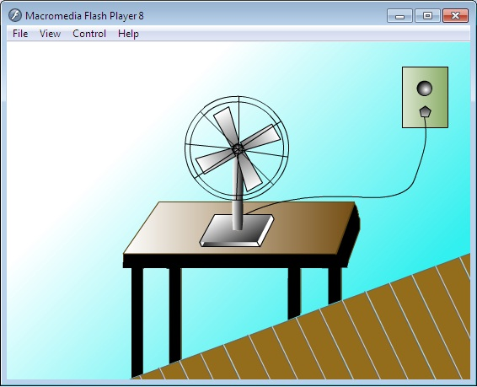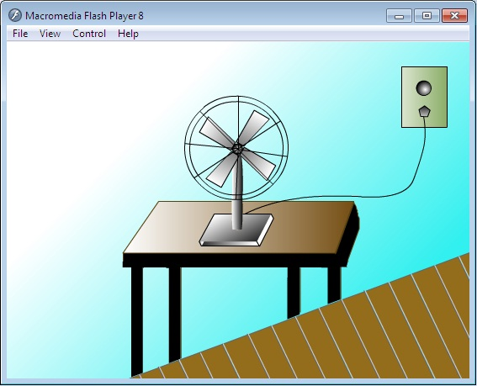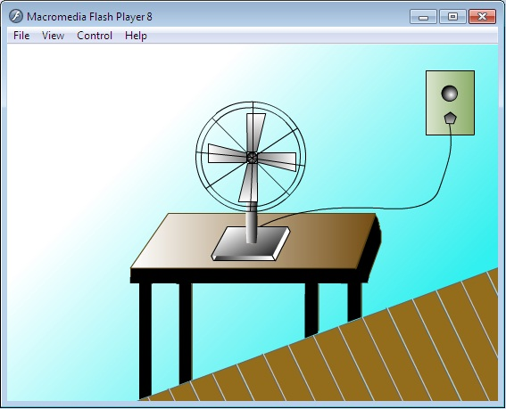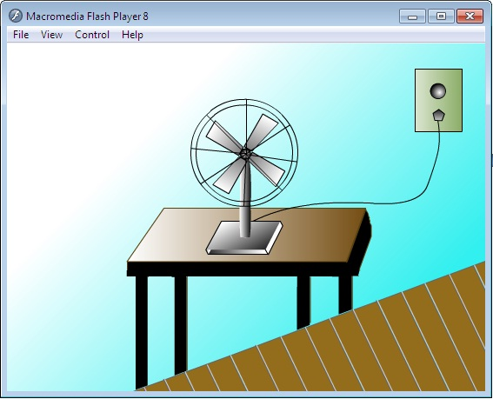

**PROGRAM 5**

**PROCEDURE TO CREATE AN ANIMATION WITH THE FOLLOWING FEATURES. “*WELCOME”***

**\*Letter should appear one by one.**

**\*The fill color of the text should change to a different color after the display of the full word.**

1. Go to **start**=> **macromedia**=> click on **flash document**.
2. Choose the textbox from the tool bar. Type the word as **“WELCOME”** on the **layer 1**.
3. Select the complete word, increase its font size and change the color.
4. In the timeline window, select the **1st frame**=> right click on it=> choose insert key frame. Now delete a last letter { E } and change the color of the remaining word.
5. Repeat the above procedure till you delete the every word in **“WELCOME”.**
6. Now select all the key **frames**=> right click=> choose **“Reverse key frames”**.
7. After reversing the frames copy the last frame and paste on its next. Now in the new frame select all the complete word **“WELCOME”** and change the color.
8. Finally go to **control**=>click on **test movie** you will get the required animation.

**OUTPUT:-**

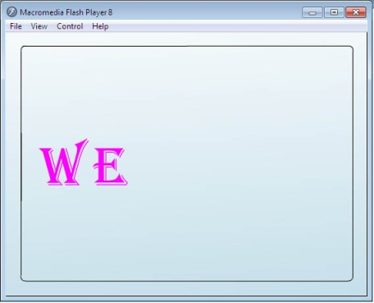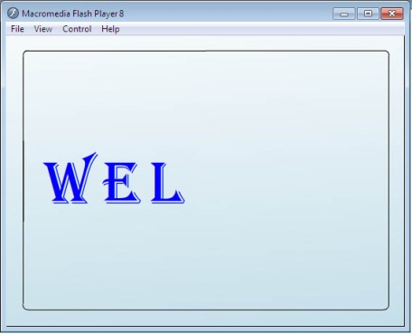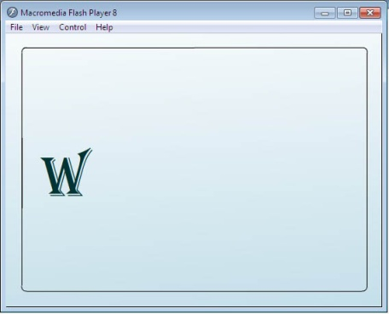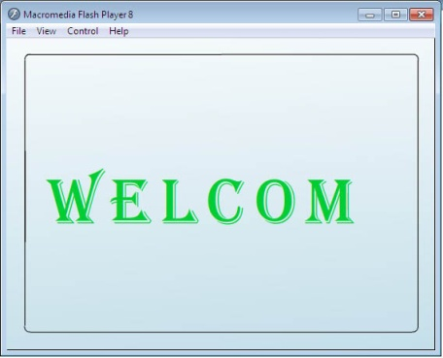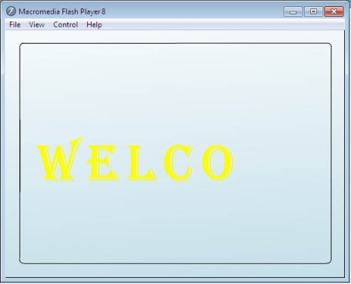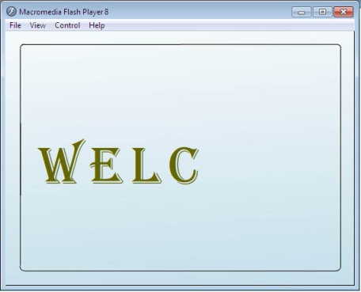

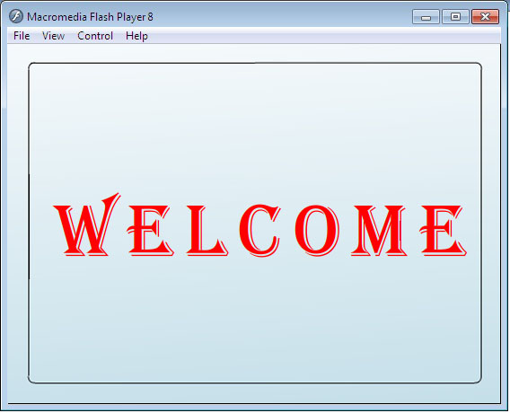

**PROGRAM 6**

**PROCEDURE TO SIMULATE A BALL HITTING ANOTHER BALL.**

1. Go to **start**=> **macromedia**=> click on **flash document**.
2. Choose the **circle** option displayed in the **toolbar**. Create two circles at the opposite ends.
3. Go to **frames**=> right click on the 1st blank frame and click **insert key frames**.
4. Select the 1st ball and make it to move towards the other end till it touches.
5. Change the shape of the ball using **free transform** tool as soon as the two balls touches each other. After hitting each other make them to move towards the opposite direction.
6. Before moving to the opposite directions bring back the balls to its original shapes.
7. Finally test the animation by selecting **control**=> **movie clip**.

**OUTPUT:-**

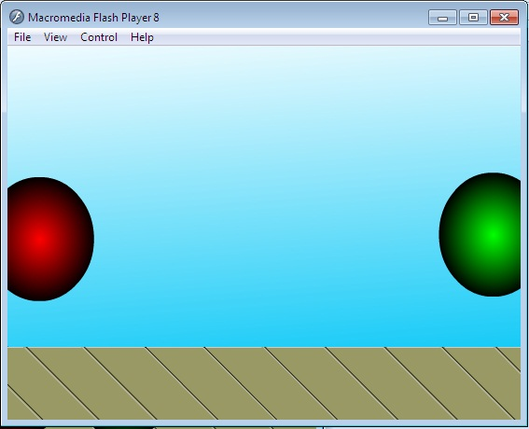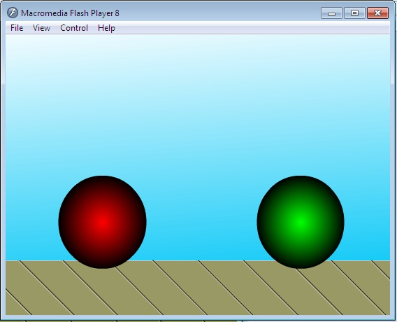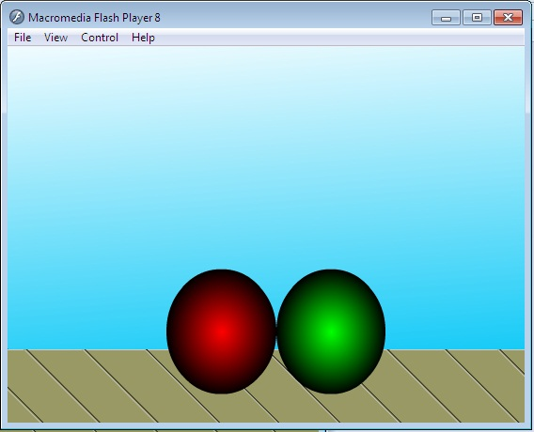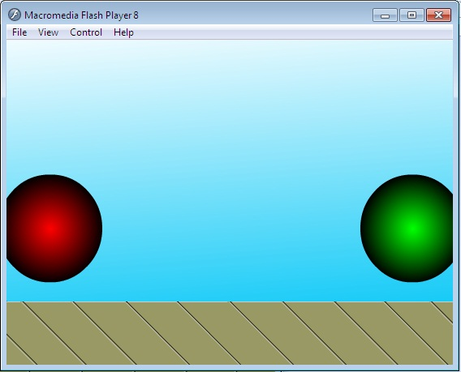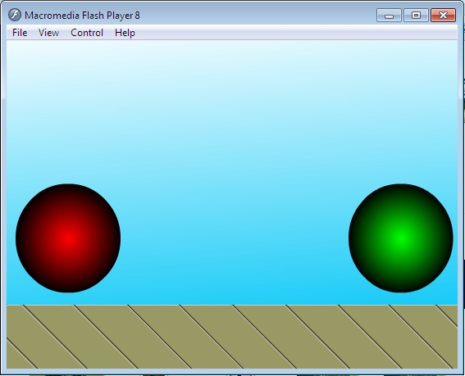

**PROGRAM 7**

**PROCEDRE TO CREATE AN ANIMETED CURSOR USING STARTDRAG(“MBA”, TRUE); MOUSE.HIDE();**

1. Go to **start**=> **macromedia**=> click on **flash document**.
2. Insert or draw any object of your choice for example butterfly in this example.
3. Using **free** **transform** tool select the object-right click=> **convert** **to** **symbol**=> select **movie** **clip** give the **name(mm)**=>click **ok**.
4. Enter the instance name as (mm) using the **property tool box**. (same as the movie clip name).
5. Select the object using **free** **transform** tool=> go to **modify**=> **timeline=> distribute to layers**.
6. Select **layer1** and rename it to **Action.**
7. Select the first key frames in the **action** **layer**=> go to **windows**=>click **action**.
8. You will get **action** **frame**=> enter the following code in the action frame.

Mouse.hide();

this.mm.onEnterFrame=function()

{

startDrag(this.true);

};

1. Finally test by selecting **control**=> **movie clip**.

**OUTPUT:-**

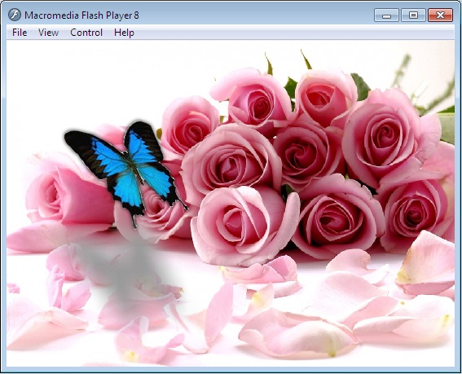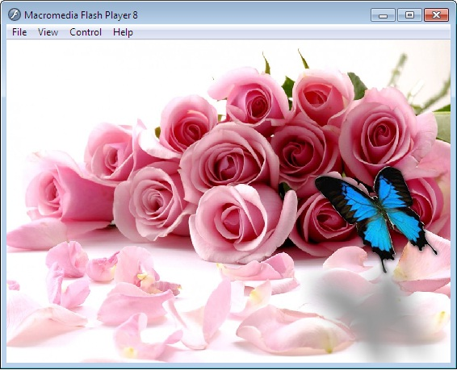

**PROGRAM 8**

**PROCEDRE TO DESIGN A VISITING CARD CONTAINIG ATLEAST ONE GRAPHIC AND TEXT INFORMATION.**

1. Open **Adobe** **Photoshop** **7.0**=> **file**=> **new**=> enter **height 200** and **width 400** for the visiting card.
2. Select the **rectangle** **tool** in the **tool** **bar** and **draw** on the half of the work area=> color it. Repeat the same for remaining half=> use different colors to color.
3. Copy any picture of your choice and place it on the work area=> resize it using **transform** **tool**.
4. Select the **text** **tool** and type text of your choice.
5. Apply the text **font** **size**, **color** and **style** of your choice.

**OUTPUT:-**



**PROGRAM 9**

**PROCEDRE TO PREPARE A COVER PAGE FOR THE BOOK IN YOUR SUBJECT AREA PLAN YOUR OWN DESIGN.**

1. Open **Adobe** **Photoshop** **7.0**=> **file**=> **new**=> enter **height 500** and **width 400** for the cover page.
2. Select the **rectangle tool** in the **tool bar** and draw on the half of the work area=> color it repeat the same for remaining area=> use different colors to color.
3. Copy any picture of your choice and place it on the work area=> resize it using **free transform** **tool**.
4. Select the **text** **tool** and type text of your choice.
5. Apply the text font size, color and style of your choice.
6. Go to **layer**=> **layer** **style**=> **blended** **option**=> select **glow** options of your choice.
7. Apply the effect using **blended** **options**.

**OUTPUT:-**



**PROGRAM 10**

**PROCEDRE TO EXATRACT THE FLOWER ONLY FROM GIVEN PHOTOGRAPHIC IMAGE AND ORGANISE IT ON A BACKGROUND. SELECTING YOUR OWN BACKGROUND FOR ORGANISATION.**

1. Select **Adobe** **Photoshop** **7.0**=> **file**=> **open**=> choose a file and open it.
2. Select the flower from the image using the **lasso** **tool**.
3. Go to **edit**=> **copy**=> Again go to **file**=> **new**=> give **height** **500** and **width** **500**.
4. Choose appropriate back group and foreground color from the tool bar.
5. Go to **edit**=> **fill**=> under use select **background** **color**=> **ok**.
6. Go to **edit**=> **paste**.

**OUTPUT:-**

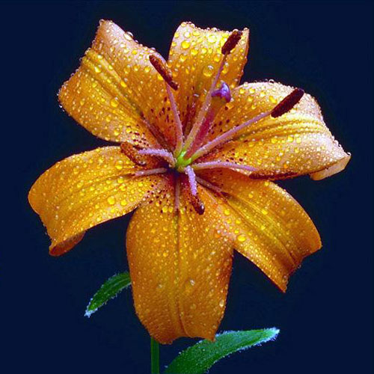

**PROGRAM 11**

**PROCEDRE TO ADJUST THE BRIGHTNESS AND CONTRAST OF THE PICTURE SO THAT IT GIVES AN ELEGANT LOOK.**

1. Select **Adobe** **Photoshop** **7.0**=> **file**=> **open**=> choose a file and open it.
2. Go to image=> Adjustments=> Brightness/Contrast.
3. After getting the Brightness/Contrast window adjust the brightness and contrast by dragging appropriate bat setting.
4. Finally save the image file.

**OUTPUT:-**

*(Before setting Brightness/Contrast)*

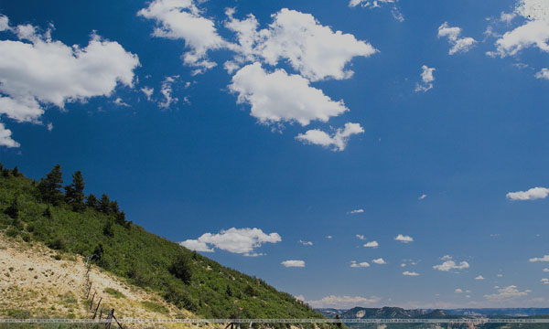

*(After setting Brightness/Contrast)*

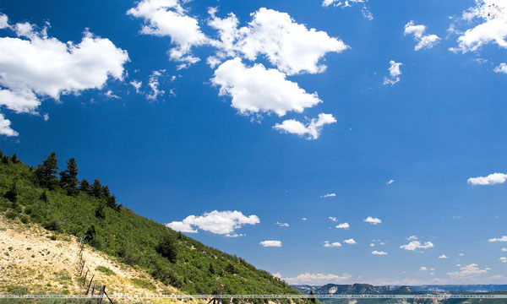

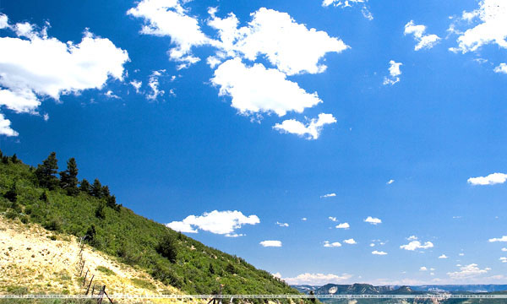

**PROGRAM 12**

**PROCEDRE TO POSITION THE PICTURE PREFERABLY ON A PLAIN BACKGROUND OF A COLOR OF YOUR CHOICE- POSITIONING INCLUDES ROTATION AND SCALING.**

1. Select **Adobe** **Photoshop** **7.0**=> **file**=> **open**=> choose a file and open it.
2. Select the flower from the image using the **lasso** **tool**.
3. Go to **edit**=> **copy**=> Again go to **file**=> **new**=> give **height** **500** and **width** **500**.
4. Choose appropriate back group and foreground color from the tool bar.
5. Go to **edit**=> **fill**=> under use select **background** **color**=> **ok**.
6. Go to **edit**=> **paste**=> Again go to **edit**=> **free** **transform** **tool**=> you will get a box around the image for scaling and rotating.
7. **Rotate** and **scale** as per your requirement=> and press **apply**.
8. Save the image.

**OUTPUT:-**

*(Before scaling and rotation)*

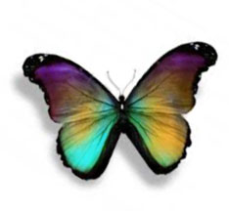

*(After scaling and rotation)*

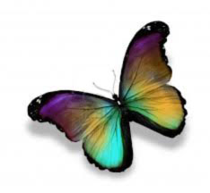

**PROGRAM 13**

**PROCEDRE TO REMOVE THE ARROWS AND TEXT FROM THE GIVEN PHOTOGRAPHIC IMAGE.**

1. Open Adobe **Photoshop** **7.0**=> **file**=> **open**=> choose a file with arrows and some text=> open it.
2. Select the arrows from **lasso** **tool** from the **tool** **bar** which you want to **delete**=> go to **edit**=> **cut**.
3. Select the text on the image using **text** **tool** and press **delete**.
4. Save the file.

**OUTPUT:-**

*(Original image)*

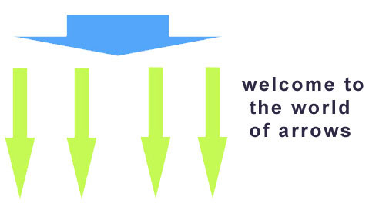

*(After removing arrows and text)*

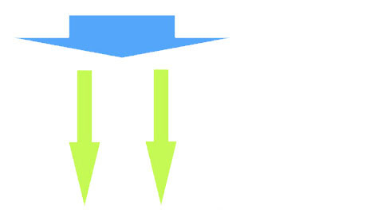

**PROGRAM 14**

**PROCEDRE TO USE APPROPRIATE TOOL(S) FROM THE TOOLBOX CUT THE OBJECTS FROM 3 FILES (F1.JPG, F2.JPG AND F3.JPG). ORGANISE THEM IN A SINGLE FILE AND APPLY FEATHER EFFECTS.**

1. Open **Adobe** **Photoshop** **7.0**=> **file**=> **open** f1.jpg.
2. Select the flower in it using the **lasso** **tool**=> right click=> feather=> give feather radius 20 pixels.
3. Go to **edit**=> **copy**=>open a new **file** with **height** **500** and **width** also **500=**> paste the flower.
4. Repeat the same procedure for f2.jpg and f3.jpg=> select the flower=> give feather effect=> **edit**=> **copy**=>open a new **file=**> **paste**.
5. You will get an final single file with 3 flowers from different files.
6. Save the image.

**OUTPUT:-**

*(F1.JPG) (F2.JPG) (F3.JPG)*

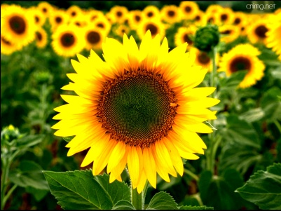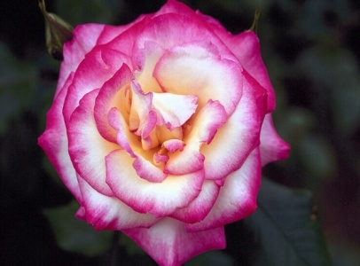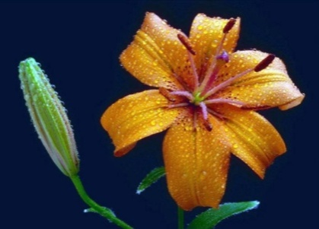

*(FINAL IMAGE)*

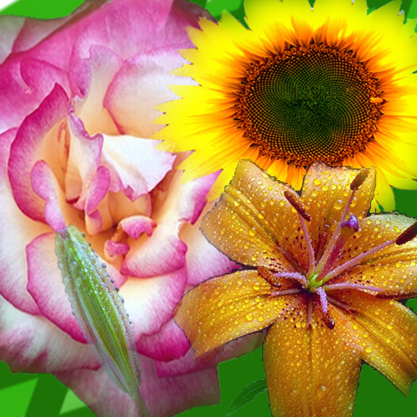

**PROGRAM 15**

**PROCEDRE TO DISPLAY THE BACKGROUND GIVEN (FILE NAME: GARDEN.JPG) THROUGH YOUR NAME USING MASK.**

1. Go to **start**=> **macromedia**=> click **flash** **document**.
2. Go to **file**=> **import**=> open **external** **library**=> select a background image click **open**.
3. The selected image will be stored in your library. Open library and **drag** the image on the work area by selecting the image.
4. Go to **view**=> **zoom** **out**=> resize the picture such that it should fit the work area.
5. Insert **layer2** => choose the **text** **tool** from the **toolbar** and type CIT.
6. Select the text to change its font size and color of your choice. Place the text on the left of the work area.
7. **Right** **click** on the 70th **key** **frame** of **layer2** and insert a **key** **frame**. Move the text to right side of the work area=> **right** **click** on the 69th frame of **layer2**=> choose **create** **motion** **tween**.
8. Right click on **layer2** choose the option **mask**.
9. Go to **control**=> **test** **movie** to see the animation.

**OUTPUT:-**

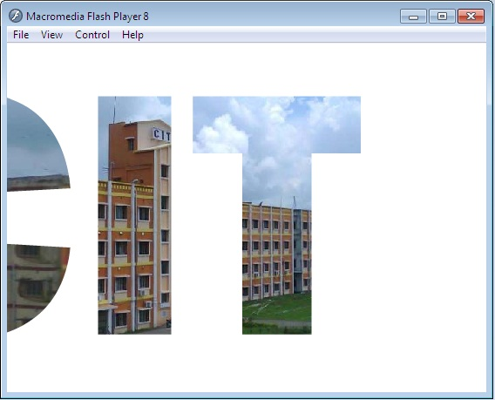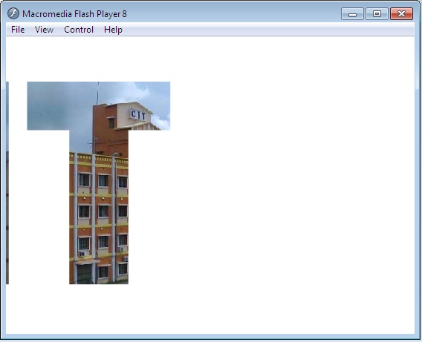

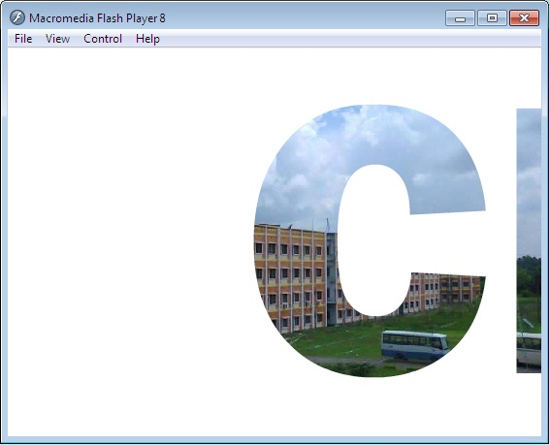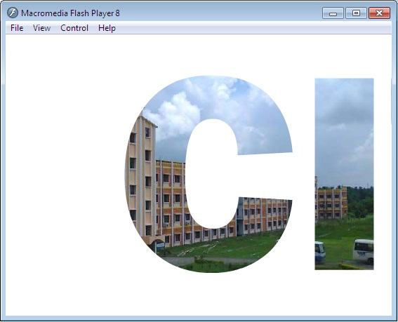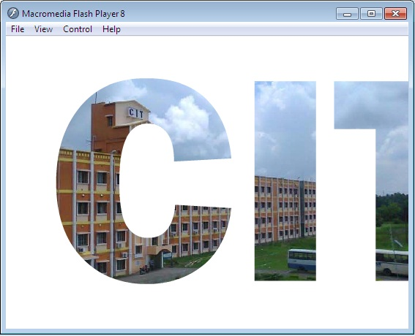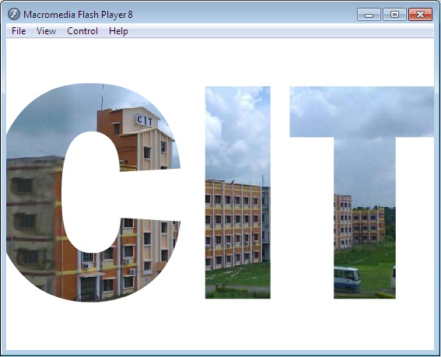

**PROGRAM 16**

**PROCEDRE TO MAKE ANYONE OF ONE OF THE PARROTS BLAK AND WHITE IN A GIVEN PICTURE.**

1. Open **Adobe** **Photoshop** **7.0**=> **file**=> **open** original parrot picture.
2. Select a parrot from the image using the **lasso** **tool** from the **toolbar**.
3. After selection=> go to **image**=> **adjustments**=> **desiderate**.
4. Then selected picture will now turn to black and white.
5. Save as modified image.

**OUTPUT:-**

*(Original picture)*

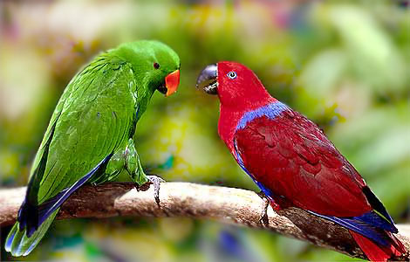

*(Modified picture)*

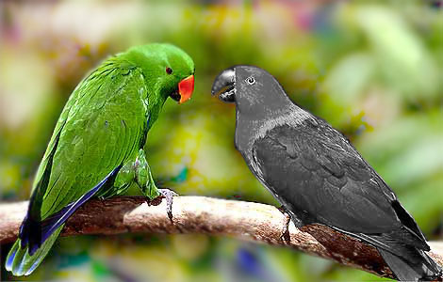

**PROGRAM 17**

**PROCEDURE TO CHANGE A CIRCLE INTO A SQUARE USING FLASH.**

1. Go to **start**=> **macromedia**=> click on **flash document**.
2. Choose the **circle** option displayed in the **toolbar**. Draw a circle on the work area. Color it.
3. Click on 40th key frame=> insert new key frame.
4. Select the last key frame=> draw a rectangle on the circle by selecting the rectangle toolbar so that it will cover the circle. Color the rectangle by the different color.
5. Again click on the last frame=> under properties=> under tween=> change the option shape from none.
6. Then again select the last but one frame=> go to properties=> tween=> change to shape
7. Go to control=> test movie=> see the circle changing into rectangle.

**OUTPUT:-**

